Project Design Phase-II
Data Flow Diagram & User Stories

Date | 26-11-2025
Name | Yakshagaraj A G
Project Name | Online Bookstore
Maximum Marks | 4 Marks

Data Flow Diagrams:
A Data Flow Diagram (DFD) explains how data moves through the Online Bookstore platform. It shows how users browse, search, purchase books, and how the system processes these operations.

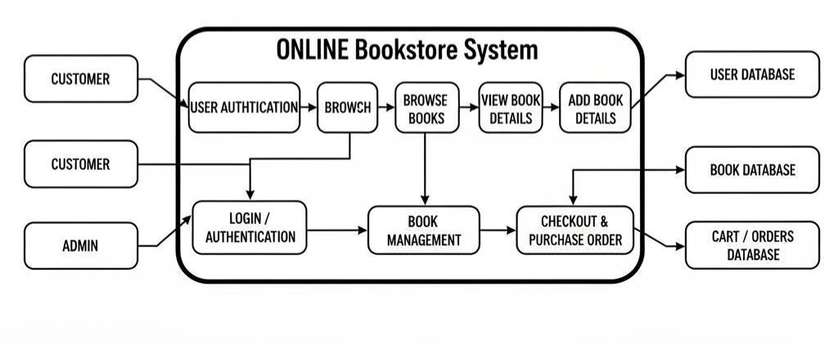

User Stories
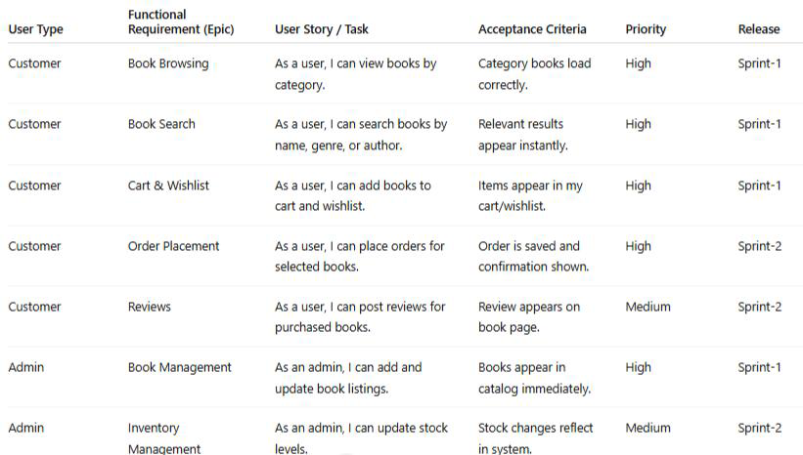
User Story Table – Online Bookstore

